**Tic Tac Toe Game App in BackBoneJS**

**Initial Home Page**

* This Game App is developed in BackBoneJS Framework and below is the first screen for the very first time.
* Below is the Home page
  + You can find the two input box to enter the first player and second player name.
  + Below there is Leader Board which shows the Winner Name and their points which is number of winning games.

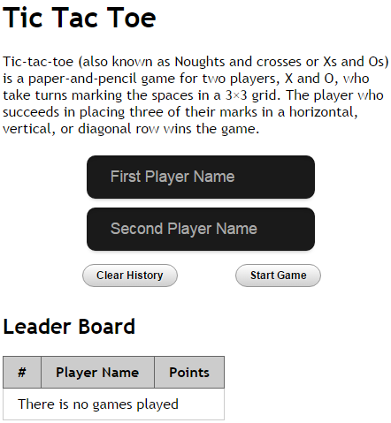

**Player Entry Form**

Entered the Players Name and Clicked **Start Game**

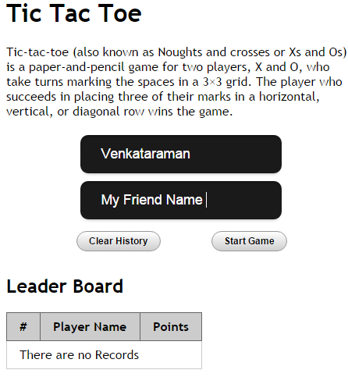

**Initial Game Page**

* After Clicked **Start Game,** You can see Player 1 and Player 2 Name with their icon representation
* **“Turn for**” explain who has got the chance to play and You can find “Game Started” which is for Game Status.

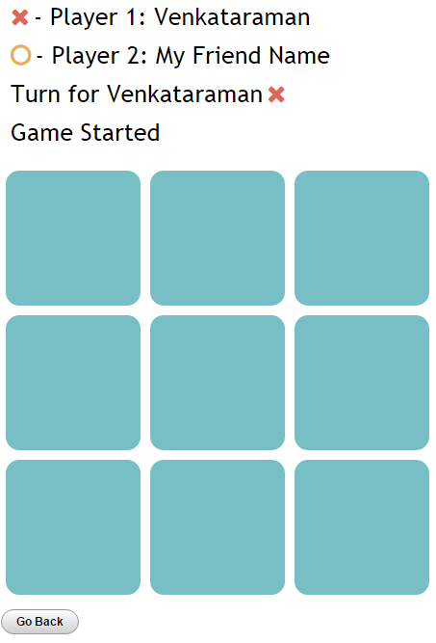

**Game Won Page**

This is how it shows , when the player Won the game !

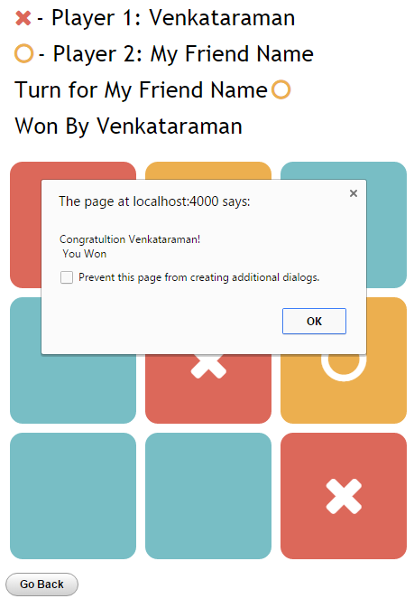

**Leader Board Page**

* Leader Board will get updated with Winners Name and their number of winning as points.
* Last Player Names will be stored to avoid entering again.

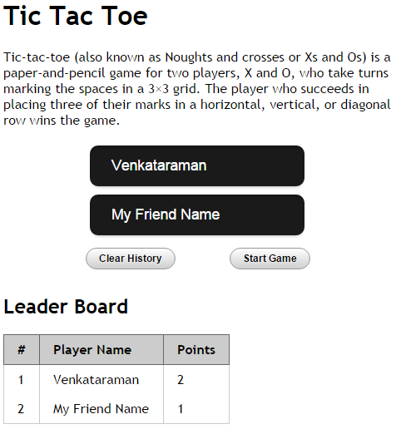

**Game Draw Page**

This is how it shows , when the game drawn, By the way, there is no track for tie games in player pointing system of Leaders board.

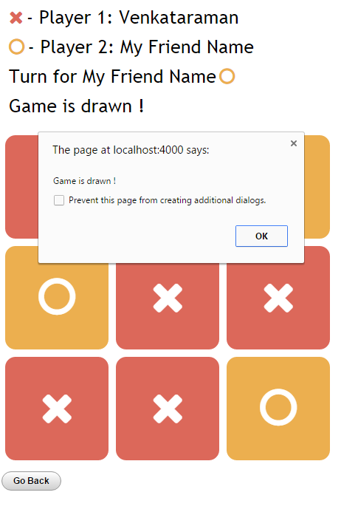

Thank You